ASSIGNMENT 3

Name: Khushi Sharma
Roll No: 2301410007
Course: BTech CSE (Cyber Security)
(SCHEDULING)

1. First Come First Serve Scheduling

CODE
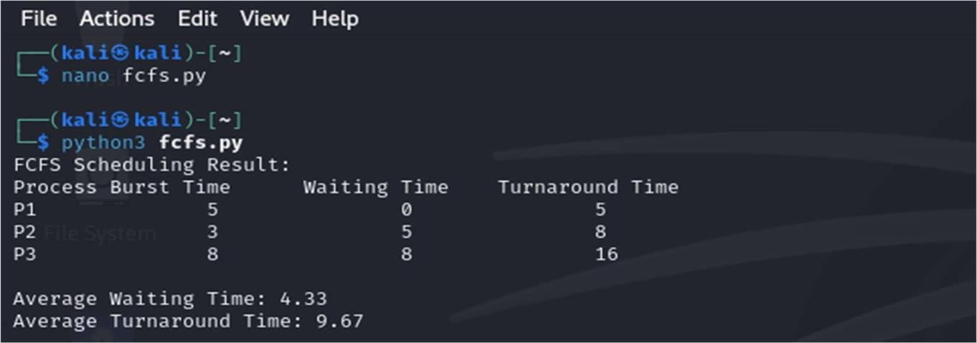
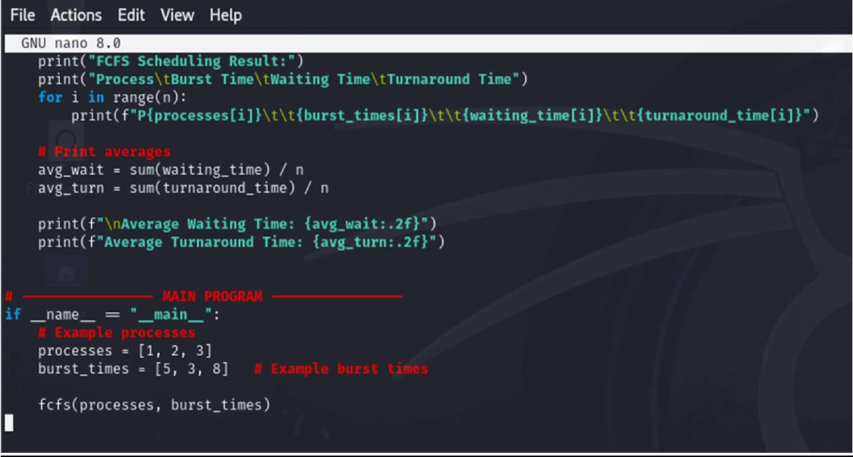

OUTPUT

- SJF (Shortest Job First)
CODE

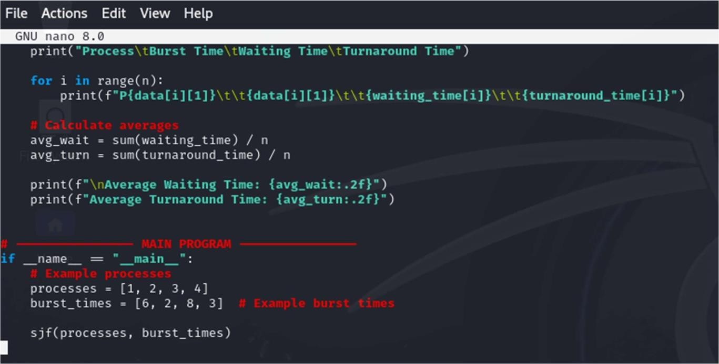

OUTPUT

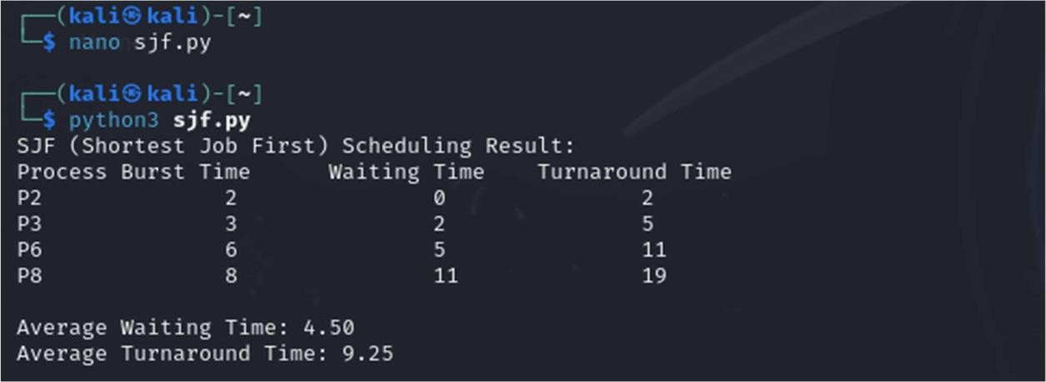
- Robin Round
CODE

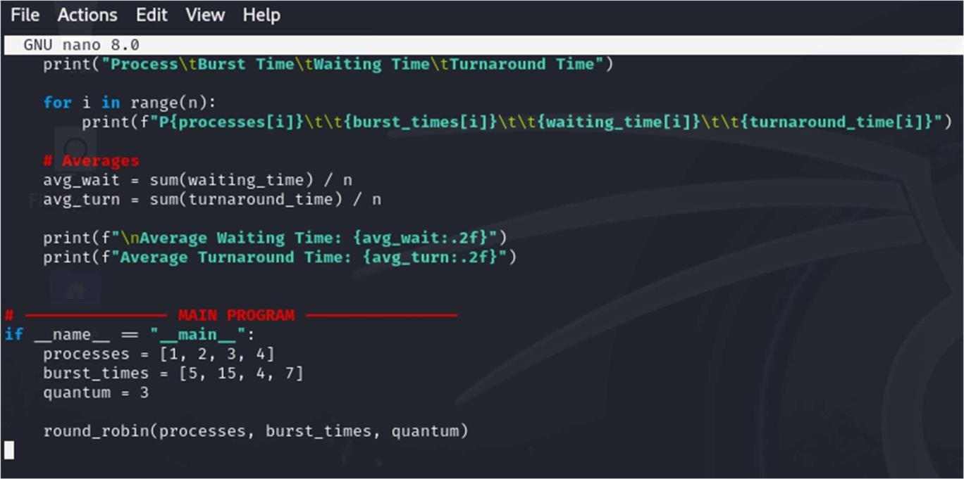

OUTPUT

